**Practical Assessment 2 – Mechanical Engineering Design and Analysis**

**Students:** Tran Anh Kiet (s3741189)

**Lecturer:** Dr. Peter Claiden

**Due date:** Friday, January 11, 2022

Table of Contents

**I.** **Introduction** 4

**II.** **Problem Statements** 5

**III.** **Methodology** 5

**1.** **Shaft** 5

**2.** **Key** 6

**3.** **Gearbox** 7

**4.** **Bearing** 8

**5.** **Brake and Clutch** 8

**IV.** **Conceptual Design** 9

**1.** **Shaft** 10

**2.** **Key** 16

**3.** **Gearbox** 17

**4.** **Bearing** 19

**5.** **Brake and Clutch** 23

**6.** **Final design** 24

**V.** **Simulation and System Analysis** 25

**1.** **Motion analysis** 25

**2.** **FEA simulation** 25

**VI.** **Discussion and Conclusion** 26

**VII.** **Reference** 27

**VIII.** **Appendices** 28

**1.** **Shaft** 28

**2.** **Key** 32

**3.** **Gearbox** 33

**4.** **Bearing** 43

**5.** **Brake and Clutch** 47

**6.** **Final design** 49

Figure 1: Illustration of wind turbine components 4

Figure 2: A simplified wind turbine. 5

Figure 3: An example of square key in the shaft. [1] 6

Figure 4: The reverted compound gear train. [2] 7

Figure 5: An example of disk clutch. [4] 9

Figure 6: Free body diagram of main shaft. 11

Figure 7: The shear force and bending moment diagram of main shaft. 11

Figure 8: Free body diagram of high-speed shaft. 12

Figure 9: The shear force and bending moment diagram of high-speed shaft. 13

Figure 10: Free body diagram of shaft in the gearbox. 14

Figure 11: The shear force and bending moment diagram of high-speed shaft. 15

Figure 12: The inverted compound gear train. [2] 17

Figure 13: Catalogue of 300mm inner diameter cylindrical roller bearing from SKF. [10] 20

Figure 14: Catalogue of 300mm inner diameter cylindrical roller bearing from SKF. [10] 21

Figure 15: Catalogue of 140mm inner diameter cylindrical roller bearing from SKF. [10] 22

Figure 16: Catalogue of 200mm inner diameter cylindrical roller bearing from SKF. [10] 23

Figure 17: The final design without bedplate. 24

Figure 18: The final design with bedplate. 24

Figure 19: Angular velocity of the high-speed shaft when the main shaft’s angular velocity is 60RPM. 25

Figure 20: Mesh, Stress, Deformation, and Strain analysis of main shaft. 26

# **Introduction**

The idea of this Practical Assignment 2 - Mechanical Engineering Design and Analysis is working on an industrial engineering project as an engineer in a company. The task involves designing horizontal axis wind turbines for an offshore wind farm that is around 20 kilometers from the coast. The wind turbine works as the mechanism. Its operation is turning the kinetic energy in wind into mechanical power which is then utilized to generate electricity by turning a generator. Nowadays, the wind turbines come in a variety of sizes and types, but they all have the same basic components.

Figure : Illustration of wind turbine components

A gearbox is used in a wind turbine to enhance the rotational speed between the main shaft, which is connected to the hub by a bearing, and the high-speed shaft, which is connected to the generator. The gearbox and the high-speed shaft are also connected by a brake which is used for stopping the generation of power when it is necessary or for emergency situations. For the system which I’m going to design, the wind turbine will be the simplified version. The fundamental design parameters of the wind turbine include of bearing, main shaft, high-speed shaft, gear in the gearbox, brake, and key.

Figure : A simplified wind turbine.

# **Problem Statements**

There are some primary design specifications for the wind turbine. Firstly, weight and size are optimized to be as small as possible, and material is selected based on operational conditions. For the shaft, the length of main shaft is about 0.15 m and high-speed shaft is 0.1 m and they should be in line. The axial load (thrust) on the bearing from a drag to lift ratio of the blades equal to 0.2. The center of lift of the blades is 10m from the centerline of the hub, bearing selection and shaft key must meet operational conditions. For the gearbox, transmission ratio, gear type and arrangement must meet operational conditions. The operational conditions of the design are the blades will rotate at 60 RPM while the generator will spin at 750 RPM to create 3 MW (Maximum) of useable electricity at maximum operational wind speed. The powertrain, which includes the generator, has an overall efficiency of 80%. Furthermore, the system is planned to run continuously for 8 years, reliability is 99%, and safety factor is 2 for all parts. The other variables and coefficients will be chosen based on our assumption.

# **Methodology**

## **Shaft**

In term of shaft design, there are two types of shafts to consider: the main shaft and the high-speed shaft. For the main shaft, it is influenced by the wind speed from the blades which will rotate 60 RPM at maximum operating. Similarly, the high-speed shaft is affected by the speed from the generator turns at 750 rpm to provide 3 MW of power at maximum operating. Furthermore, there is a shaft which we need to design. It is the shaft in the gearbox which is used to connect gear 2 and 3.

The three shafts are influenced by different conditions, so the method used to compute the diameter of each shaft will differ. However, the general method is that. Initially, the material will be chosen based on the function of these shaft. Then, we will determine the force, bending moment, torque which apply on the shaft. The minimum diameter of the shaft is found based on Distortion Energy Theory (DET) and Maximum Shear Stress Theory (MSST).

## **Key**

In this system, torque must be transferred between shafts and gears, hubs. The key helps in this process by preventing slippage between the two sections. In term of key design in wind turbine, square keys will be selected to link the main shaft with the gearbox and the high-speed shaft with the gearbox.

Figure : An example of square key in the shaft. [1]

In order to design the key, we need to determine material of the key then find stress in key. And it can be found by the equation of torque $T=Fr (N.m)$.

Where:

F is a tangential force located at the shaft surface (N).

r is the radius of the shaft (m).

Then calculating the required length of the square key with the width $w≈\frac{D}{4} [1]$ by:

$$L=\frac{2Fn}{S_{y}w} [1]$$

Where:

F is the force at the shaft surface (N).

$S_{y}$ is the yield strength (Pa).

n is the safety factor.

w is the width of square key (m).

## **Gearbox**

As the main shaft and high-speed shaft should be in line, the reverted compound gear train is chosen.

Figure : The reverted compound gear train. [2]

Then we got equation of reverted compound gear train:

$$\frac{ω_{in}}{ω_{out}}=\frac{N_{2}N_{4}}{N_{1}N_{3}} [2]$$

From this equation we can calculate the transmission ratio by angular velocity. Then determining number of teeth of each shaft. Next, we find parameters which are used for gear selection from catalogue: material, module, pitch diameter, bore diameter, allowable torque, pressure angle, etc.

## **Bearing**

In the main shaft of a wind turbine, roller bearings are usually used. Since it has a higher capability for combining loads and withstand significantly greater static and dynamic (shock) loads [11]. Therefore, cylindrical roller bearing is selected for the main shaft. According to the provided operational conditions are 8 years lifespan for the system as well as the bearing, 99% of reliability, and safety factor of 2.

Hence, we got equation to calculate the catalog load rating is:

$$C_{10}≈a_{f}F_{D}{\left[\frac{x_{D}}{x_{0}+\left(θ-x_{0}\right){\left(1-R_{D}\right)}^{\frac{1}{b}}}\right]}^{\frac{1}{a}} [3]$$

Where:

|  |  |
| --- | --- |
| Design life $x_{D}=\frac{L_{D}}{L_{R}}=\frac{L_{D}n_{D}60}{L_{10}}$. $F_{D}$ is the design load (N). $a_{f}$ is the safety factor.  *a* = 10/3 for roller bearing. $R_{D}$ is the reliability. | According to Bearing Design – Note 1, assuming the Weibull parameters: $$x_{0}=0.02,$$ $$\left(θ-x_{0}\right)=4.439,$$ $and b=1.483$. |

## **Brake and Clutch**

For the brake design, electrical and mechanical brakes are the two most common forms of wind turbine brakes. However, in bigger wind turbines, electrical wind turbine brakes are rarely used. Hence, in this case we decide to design Disk Clutches and Brakes for the brake system of the wind turbine. This type of brake uses frictional contact between two or more surfaces to couple the input and output sides together to slow down or stop the system.

Figure : An example of disk clutch. [4]

The brake will be placed at the high-speed shaft, and we need to determine the material of the brake. Then, using disk clutch equation to find the inside and outside radius, the maximum normal force that can be applied to the clutch.

# **Conceptual Design**

For the material of the shafts and gears of the wind turbine, we select EN8 and 080M40 steel. It is a medium carbon engineering steel with good mechanical qualities that is widely used in the construction of mechanical parts including general axles and shafts, gears, bolts, and stud bolts. This material has BS970 standard and the yield strength Sy of 280 MPa, ultimate tensile strength Su of 550 MPa. In addition, we should select a stronger material for the key, which will prevent it from breaking during system operation. EN8 and 080M40 steel with hardened and tempered + turned or ground condition is selected. It has yield strength Sy of 465 MPa, ultimate tensile strength Su of 700-850 MPa. [5]

For the wind turbine has power of 3MW, the mass of blade assembly is about 12474 kg [6].

Then the weight of it is $W=m×g=12474×9.81=122.37 kN$

Since the weight of blade assembly is 122.37 kN and weight is a force which opposes the upward force of lift, so lift equals to -122.37 kN. For the drag to lift ratio of the blades equal to 0.2 $\left(D/L=0.2\right)$, then drag equals to $-122.37×0.2=-24.474 kN$. Moreover, drag is a force which opposes the force of thrust or axial load, hence thrust or axial load equals to 24.474 kN. [7]

From the Mean Wind Speed Site A of Wind Data, eliminating wind speeds above 9.16m/s (storm conditions) and below 5.43m/s (calm). Then Bin Size Interval equal to Wind Speed Range divide Number of frequencies in the range: Bin Size Interval $=(9.16-5.43)/10=0.373$ m/s.

Hence, wind speed at maximum frequency $=5.43+(0.373×6)=7.668$ m/s.

This is 0.8 (7.688/9.16) of the maximum wind velocity and with the generator turns at 750 RPM to provide 3 MW (Maximum), therefore rated power (torque) output is $0.8×3×{10}^{6}W=2.4×{10}^{6}W.$ In addition, the powertrain, including the generator, has an overall efficiency of 80%.

Then we got equation to find angular velocity in rad/s and torque of high-speed shaft or output:

$$ω=\frac{2π}{60}×N=\frac{2π}{60}×750=78.54 \left(\frac{rad}{s}\right);T_{hs}=\frac{H}{ω}=\frac{2.4×{10}^{6}×80\%}{78.54 }=24.45 kN.m.$$

With gear ratio equals to:

$$\frac{ω_{in}}{ω_{out}}=\frac{60}{750}=\frac{1}{12.5}=\frac{T_{out}}{T_{in}}=\frac{T_{hs}}{T_{m}}. [8]$$

Hence, torque of the main shaft or input is:

## **Shaft**

* 1. **Main shaft**

Assuming the length of the main shaft is 1.5 m. The main shaft is applied by the radial and axial loading that are 122.37 kN and 24.474 kN respectively as well as torque $T_{m}$ is 305.63kN.m. Moreover, assuming the mass of the gear 1 of the gearbox is about 50 kg. Comparing with the mass of the blade assembly is about 12474 kg, as we can see load from gear 1 won’t affect much to the shaft. Hence, any load produced by the gearbox can be ignored. The free body diagram is:

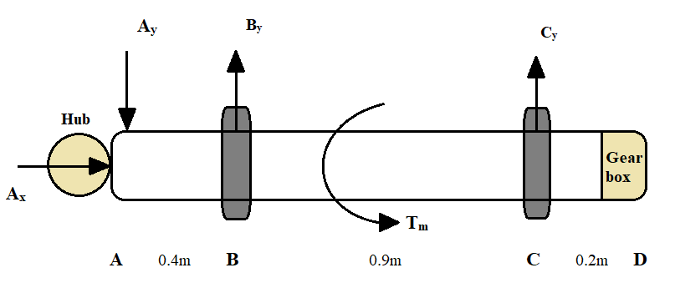

Figure : Free body diagram of main shaft.

**Calculation:**

From the FBD above, Ax and Ay are axial load and radial load respectively. By and Cy are the reaction forces of bearing at B and C. Applying equilibrium condition, we got:

$$\left(↑\right)\sum{F_{y}=0=}{-A}_{y}+B_{y}+C_{y}⇔B_{y}+C_{y}=A_{y}=122.37 kN.$$

Moment at point C:

$$\left(↺\right)\sum{M_{C}=0=}0-B_{y}×0.9+A_{y}×1.3⇒B_{y}=\frac{122.37×1.3}{0.9}=176.76 kN.$$

$$⇒C_{y}=122.37-176.76=-54.39 kN=54.39 kN\left(↓\right).$$

Then we got the shear force and bending moment diagram:

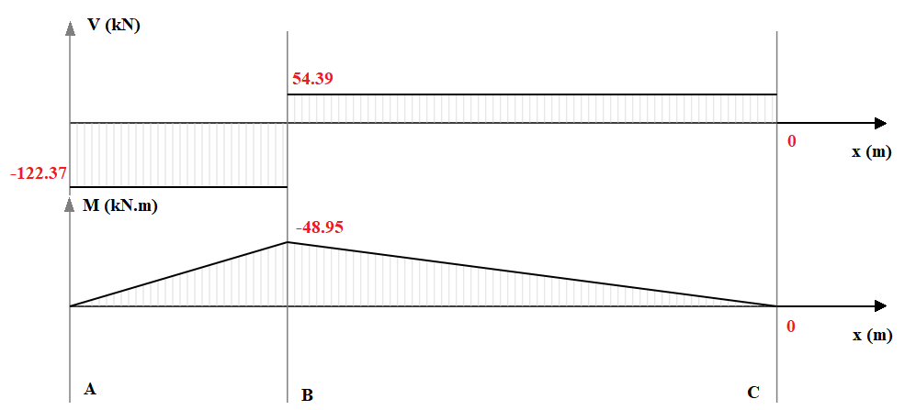

Figure : The shear force and bending moment diagram of main shaft.

From the figure above, we can see that the maximum bending moment is equal to 48.95 kN.m. From the information above, the DET and MSST equation to calculate smallest safe diameter are [9]:

|  |  |
| --- | --- |
| **DET** | **MSST** |
| $$\frac{4}{πd^{3}}\sqrt{{\left(8M+Pd\right)}^{2}+48T^{2}}=\frac{S_{y}}{n_{s}}$$ | $$\frac{4}{πd^{3}}\sqrt{{\left(8M+Pd\right)}^{2}+64T^{2}}=\frac{S_{y}}{n_{s}}$$ |
| **Where:**  M = 48.95 kN.m, P = 24.474 kN, T = 305.63 kN.m, ns = 2, Sy = 280 MPa = 280*106 Pa | |
|  |  |

Therefore, the smallest safe diameter is 0.2696m or 26.96cm (DET method). Then the selection for the main shaft’s diameter is 0.30m or 30cm.

* 1. **High-speed shaft**

Assuming the length of the high-speed shaft is 1 m. It is applied by a torque Ths is 24.45 kN.m and a radial load from gear 4 of gearbox. Suppose that gear 4 has a mass of 20 kg ($W=m×g=20×9.81=196.2 N$. The free body diagram is:

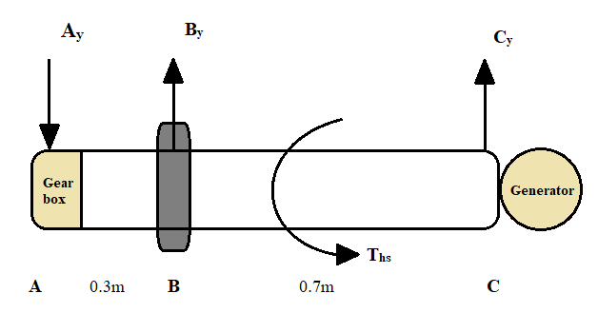

Figure : Free body diagram of high-speed shaft.

**Calculation:**

From the FBD above, Ay is radial load and By and Cy is the reaction force of bearing at B and C. Applying equilibrium condition, we got:

$$\left(↑\right)\sum{F_{y}=0=}{-A}_{y}+B_{y}+C_{y}⇔B_{y}+C_{y}=A_{y}=196.2 N.$$

Moment at point C:

$$\left(↺\right)\sum{M_{C}=0=}0-B_{y}×0.7+A_{y}×1⇒B_{y}=\frac{196.2×1}{0.7}=280.3 N.$$

$$⇒C_{y}=196.2-280.3=-84.1 N=84.1 N\left(↓\right).$$

Then we got the shear force and bending moment diagram:

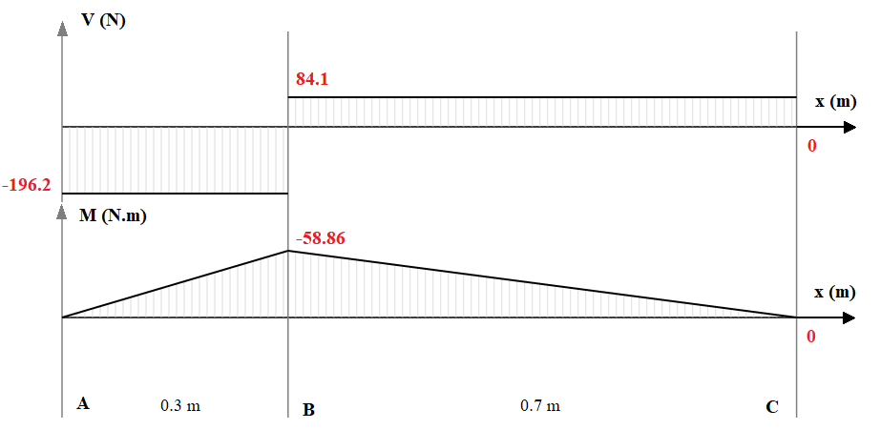

Figure : The shear force and bending moment diagram of high-speed shaft.

From the figure above, we can see that the maximum bending moment is equal to 58.68 N.m. From the information above, the DET and MSST equation to calculate smallest safe diameter are [9]:

|  |  |
| --- | --- |
| **DET** | **MSST** |
| $$d={\left(\frac{32n_{s}}{πS_{y}}\sqrt{M^{2}+0.75T^{2}}\right)}^{\frac{1}{3}}$$ | $$d={\left(\frac{32n_{s}}{πS_{y}}\sqrt{M^{2}+T^{2}}\right)}^{\frac{1}{3}}$$ |
| **Where:**  M = 58.68 N.m, T = 24.45 kN.m, ns = 2, Sy = 280 MPa = 280*106 Pa | |
|  |  |

Therefore, the smallest safe diameter is 0.115m or 11.5cm (DET method). Then the selection for the main shaft’s diameter is 0.14m or 14cm.

* 1. **Shaft in the gearbox**

Assuming the length of the high-speed shaft is 0.7 m. It is applied by a torque T, and it equals to

$$\frac{ω_{in}}{ω_{out}}=\frac{60}{750}=\frac{1}{12.5}=\frac{T_{out}}{T_{in}}=\frac{T}{T_{m}}×\frac{T_{hs}}{T}.$$

$$⇒\frac{T}{T_{m}}=\sqrt{\frac{1}{12.5}}=\frac{T}{305.63 kN.m}⇒T=86.44 kN.m.$$

Furthermore, a radial load from gear 2 and gear 3 of gearbox are also applied to the shaft. Suppose that gear 3 has a mass of 50 kg ( $W=m×g=50×9.81=490.5 N)$ and gear 2 has a mass of 20 kg ($W=m×g=20×9.81=196.2 N)$. The free body diagram is:

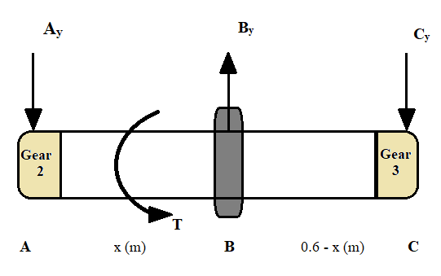

Figure 10: Free body diagram of shaft in the gearbox.

**Calculation:**

From the FBD above, Ay and Cy is radial load and By is the reaction force of bearing at B. Applying equilibrium condition, we got:

$$\left(↑\right)\sum{F_{y}=0=}{-A}_{y}+B_{y}-C_{y}⇔B_{y}=A_{y}+C_{y}=686.7 N.$$

Moment at point C:

$$\left(↺\right)\sum{M_{C}=0=}0-B_{y}×\left(0.6-x\right)+A_{y}×0.6⇒B_{y}=\frac{196.2×0.6}{0.6-x}=686.7 N.$$

$$⇒x=3/7 m.$$

Hence, the distance to maintain equilibrium from B to C is $6/{35}m$ and from A to B is $3/7m$. Then we got the shear force and bending moment diagram:

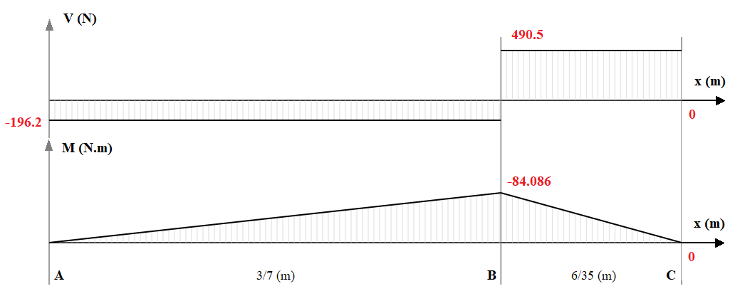

Figure 11: The shear force and bending moment diagram of high-speed shaft.

From the figure above, we can see that the maximum bending moment is equal to 84.086 N.m. From the information above, the DET and MSST equation to calculate smallest safe diameter are [9]:

|  |  |
| --- | --- |
| **DET** | **MSST** |
| $$d={\left(\frac{32n_{s}}{πS_{y}}\sqrt{M^{2}+0.75T^{2}}\right)}^{\frac{1}{3}}$$ | $$d={\left(\frac{32n_{s}}{πS_{y}}\sqrt{M^{2}+T^{2}}\right)}^{\frac{1}{3}}$$ |
| **Where:**  M = 84.086 N.m, T = $86.44 kN.m$, ns = 2, Sy = 280 MPa = 280*106 Pa | |
|  |  |

Therefore, the smallest safe diameter is 0.176m or 17.6cm (DET method). Then the selection for the main shaft’s diameter is 0.20m or 20cm.

## **Key**

**Calculation:**

* **Main shaft and gear 1**

With the diameter of the main shaft is 30cm, the width of the key is equal to $w≈\frac{D}{4}≈\frac{30}{4}≈7 cm$ and r equal to 15 cm. Moreover, T = 305.63 kN.m, ns = 2, Sy = 465MPa = 465*106 Pa.

Then, the force F at the surface of the main shaft is

$$F=\frac{T}{r}=\frac{305630}{0.15}=2037.5 kN$$

The required length of the square key is:

$$L=\frac{2Fn}{S_{y}w}=\frac{2×2037.5×{10}^{3}×2}{465×{10}^{6}×0.07}=0.25m=25cm.$$

* **High-speed shaft and gear 4**

With the diameter of the main shaft is 14cm, the width of the key is equal to $w≈\frac{D}{4}≈\frac{14}{4}≈3.5 cm$ and r equal to 7 cm. Moreover, T = 24.45 kN.m, ns = 2, Sy = 465MPa = 465*106 Pa. The force F at the surface of the main shaft is

$$F=\frac{T}{r}=\frac{24450}{0.07}=349.3 kN$$

Thus, the required length of the square key is:

$$L=\frac{2Fn}{S_{y}w}=\frac{2×349.3×{10}^{3}×2}{465×{10}^{6}×0.035}=0.1m=10cm.$$

* **Shaft in the gearbox and gear 2 & Shaft in the gearbox and gear 3**

With the diameter of the shaft is 19cm, the width of the key is equal to $w≈\frac{D}{4}≈\frac{20}{4}≈5 cm$ and r equal to 10 cm. Moreover, T = $86.44 kN.m$, ns = 2, Sy = 465MPa = 465*106 Pa. The force F at the surface of the main shaft is

$$F=\frac{T}{r}=\frac{86440}{0.1}=864.4 kN$$

Thus, the required length of the square key is:

$$L=\frac{2Fn}{S_{y}w}=\frac{2×864.4×{10}^{3}×2}{465×{10}^{6}×0.05}=0.15m=15cm.$$

## **Gearbox**

**Calculation:**

The reversed gear train's speed ratio is:

Figure : The inverted compound gear train. [2]

Since we are going to use inverted compound gear train for the gearbox, the speed ratio between the gears 1 and 2 as well as the gears 3 and 4 are to be the same. Moreover, any pair of meshing gears has a speed ratio that is inversely proportional to their tooth number, therefore:

$$\frac{ω_{1}}{ω_{2}}=\frac{ω_{3}}{ω_{4}}=\sqrt{\frac{1}{12.5}}=0.283=\frac{N_{2}}{N_{1}}=\frac{N_{4}}{N_{3}}\left(1\right) [2]$$

Since the center distance of the stages must be equal for this inverted compound gear train, we got:

$$r_{1}+r_{2}=r_{3}+r_{4}; N_{1}+N_{2}=N_{3}+N_{4} [2]$$

We have equation of circular pitch:

$$p_{c}=\frac{πd}{N}=\frac{2πr}{N}=πm⇒r=\frac{m.N}{2} [2]$$

Hence,

$$\frac{m_{1}.N_{1}}{2}+\frac{m_{2}.N_{2}}{2}=\frac{m_{3}.N_{3}}{2}+\frac{m_{4}.N_{4}}{2}$$

Assuming m1 = m2 = m3 = m4 = 25 mm or 0.025 m and the center distance is 1.4375 m or 1437.5 mm

Then we got:

$$\frac{m_{1}.N_{1}}{2}+\frac{m_{2}.N_{2}}{2}=\frac{m_{3}.N_{3}}{2}+\frac{m_{4}.N_{4}}{2}=1.4375 m$$

$$⇔0.028\left(N_{1}+N_{2}\right)=0.025\left(N_{3}+N_{4}\right)=3$$

$$⇔\left(N_{1}+N_{2}\right)=\left(N_{3}+N_{4}\right)=\frac{2.875}{0.025}=115$$

From (1) $⇒\left\{\begin{aligned}N_{2}=0.283N_{1} \\ N_{4}=0.283N_{3}\end{aligned}\right.$ then $⇒\left\{\begin{aligned}N_{1}={115}/{1.283} \\ N_{3}={115}/{1.283}\end{aligned}\right.=89.6 say 90.$

$$⇒\left\{\begin{aligned}N_{2}=115-90=25 \\ N_{4}=115-90=25\end{aligned}\right..$$

With the computed values of number of teeth on each gear, the reversed gear train's speed ratio is:

$$\frac{ω_{in}}{ω_{out}}=\frac{N_{2}N_{4}}{N_{1}N_{3}}=\frac{25×25}{90×90}=0.0772.$$

The parameters of the gears are:

|  |  |  |  |  |
| --- | --- | --- | --- | --- |
| Parameters | Gear 1 | Gear 2 | Gear 3 | Gear 4 |
| Module m (m) | 0.025 | 0.025 | 0.025 | 0.025 |
| Number of teeth N | 90 | 25 | 90 | 25 |
| Pitch diameter or Reference diameter  d $=m×N$ (m) | 2.25 | 0.625 | 2.25 | 0.625 |
| Tip diameter da (m) | 2.3 | 0.675 | 2.3 | 0.675 |
| Root diameter df (m) | 2.1875 | 0.5625 | 2.1875 | 0.5625 |
| Pressure angle *ϕ* (degree) | 20 | 20 | 20 | 20 |
| Circular pitch p $={πd}/N$ (m) | 0.078 | 0.078 | 0.078 | 0.078 |
| Tooth depth h $=2.25m$ (m) | 0.05625 | 0.05625 | 0.05625 | 0.05625 |
| Addendum ha (m) | 0.025 | 0.025 | 0.025 | 0.025 |
| Dedendum hf (m) | 0.03125 | 0.03125 | 0.03125 | 0.03125 |
| Tooth thickness s $={πm}/2$ (m) | 0.039 | 0.039 | 0.039 | 0.039 |
| Center distance a $={(d_{1}+d_{2})}/2$ (m) | 1.4375 | | 1.4375 | |
| Backlash c $=0.25m$ (m) | 6.25103 | 6.25103 | 6.25103 | 6.25103 |

## **Bearing**

* **Main shaft**

There is pair of bearings on the main shaft, the first bearing is near the hub, while the other is near the gearbox. With the reliability 99% for all parts, then the individual bearing reliability of them is $\sqrt{0.99}=0.995$.

**Calculation:**

* Design load and catalog load rating of the first bearing:

$$F_{D}=\sqrt{{176760}^{2}+{24474}^{2}}=178.45 kN.$$

$$x_{D}=\frac{L_{D}}{L_{R}}=\frac{L_{D}n_{D}60}{L_{10}}=\frac{70080×60×60}{{10}^{6}}=252.3$$

Where:

$L_{D}$ is the life of bearing which is 8 years.

$n_{D}$ is the speed of the shaft in RPM.

$L_{10}$ is life in 106 revolutions.

Thus, the design life is 252.3 times the L10 life.

Where: $a_{f}=2, F_{D}=178.45 kN, x_{0}=0.02,\left(θ-x_{0}\right)=4.439, b=1.483,a = 10/3,x_{D}=252.3$.

$$⇒C_{10}≈2×178450{\left[\frac{252.3}{0.02+\left(4.439\right){\left(1-0.995\right)}^{\frac{1}{1.483}}}\right]}^{\frac{1}{\frac{10}{3}}}=3349.88 kN$$

With the catalog load rating is calculated above and shaft’s diameter is 300mm, the roller bearing with highlighted parameter in the figure below will be selected.

Figure : Catalogue of 300mm inner diameter cylindrical roller bearing from SKF. [10]

* Design load and catalog load rating of the second bearing:

$$F_{D}=\sqrt{{54390}^{2}+{24474}^{2}}=59.64 kN.$$

$$C_{10}≈a_{f}F_{D}{\left[\frac{x_{D}}{x_{0}+\left(θ-x_{0}\right){\left(1-R_{D}\right)}^{\frac{1}{b}}}\right]}^{\frac{1}{a}}$$

Where: $a_{f}=2, F_{D}=59.65 kN, x_{0}=0.02,\left(θ-x_{0}\right)=4.439, b=1.483,a = 10/3,x_{D}=252.3$.

$$⇒C_{10}≈2×59640{\left[\frac{252.3}{0.02+\left(4.439\right){\left(1-0.995\right)}^{\frac{1}{1.483}}}\right]}^{\frac{1}{\frac{10}{3}}}=1119.57 kN$$

With the catalog load rating is calculated above, and shaft’s diameter is 300mm, the roller bearing with highlighted parameter in the figure below is selected.

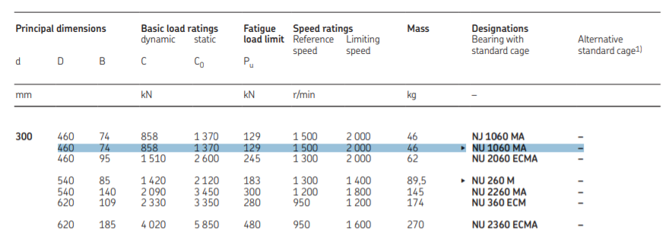

Figure : Catalogue of 300mm inner diameter cylindrical roller bearing from SKF. [10]

* **High-speed shaft**

**Calculation:**

Catalog load rating of the bearing:

$$x_{D}=\frac{L_{D}}{L_{R}}=\frac{L_{D}n_{D}60}{L_{10}}=\frac{70080×750×60}{{10}^{6}}=3153.6$$

$$C_{10}≈a_{f}F_{D}{\left[\frac{x_{D}}{x_{0}+\left(θ-x_{0}\right){\left(1-R_{D}\right)}^{\frac{1}{b}}}\right]}^{\frac{1}{a}}$$

Where: $a_{f}=2, F_{D}=280.3 N, x_{0}=0.02,\left(θ-x_{0}\right)=4.439, b=1.483,a = 10/3,x_{D}=3153.6$.

$$⇒C_{10}≈2×280.3{\left[\frac{3153.6}{0.02+\left(4.439\right){\left(1-0.99\right)}^{\frac{1}{1.483}}}\right]}^{\frac{1}{\frac{10}{3}}}=11.23 kN$$

With the catalog load rating is calculated above and shaft’s diameter is 140mm, the roller bearing with highlighted parameter in the figure below will be selected.

Figure : Catalogue of 140mm inner diameter cylindrical roller bearing from SKF. [10]

* **Gearbox shaft**

**Calculation:**

Catalog load rating of the bearing:

$$\frac{ω_{1}}{ω_{2}}=\frac{60}{ω_{2}}=\sqrt{\frac{1}{12.5}}⇒n_{D}=ω_{2}=212.13 RPM$$

$$x_{D}=\frac{L_{D}}{L_{R}}=\frac{L_{D}n_{D}60}{L_{10}}=\frac{70080×212.13×60}{{10}^{6}}=891.96$$

$$C_{10}≈a_{f}F_{D}{\left[\frac{x_{D}}{x_{0}+\left(θ-x_{0}\right){\left(1-R_{D}\right)}^{\frac{1}{b}}}\right]}^{\frac{1}{a}}$$

Where: $a_{f}=2, F_{D}=686.7 N, x_{0}=0.02,\left(θ-x_{0}\right)=4.439, b=1.483,a = 10/3,x_{D}=252.3$.

$$⇒C_{10}≈2×686.7{\left[\frac{891.96}{0.02+\left(4.439\right){\left(1-0.99\right)}^{\frac{1}{1.483}}}\right]}^{\frac{1}{\frac{10}{3}}}=16.6 kN$$

With the catalog load rating is calculated above and shaft’s diameter is 200mm, the roller bearing with highlighted parameter in the figure below will be selected.

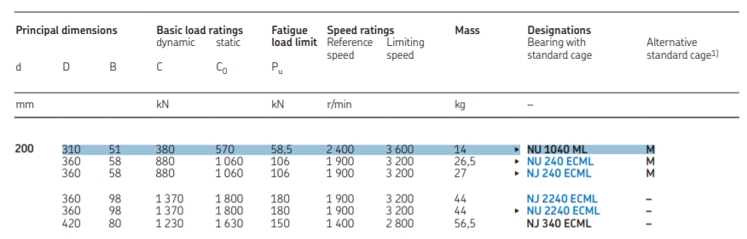

Figure 16: Catalogue of 200mm inner diameter cylindrical roller bearing from SKF. [10]

## **Brake and Clutch**

The disk brake will be made of sintered metal, and it rubs against sintered metal in dry condition. According to table 2 in Appendix, it has coefficient of friction $μ=0.35$, maximum contact pressure $p_{max}=1800 kPa$. With safety factor $n_{s}=2$, maximum torque $T_{w}=24.45 kN.m$. [4] And we want the disk brake fit to the high-speed shaft, so the inside radius of 0.14m will be chosen.

**Calculation:**

We have equation to calculate outside radius [4]:

$$r_{i}\left({r_{o}}^{2}-{r_{i}}^{2}\right)=\frac{n_{s}T_{w}}{πμp_{max}}=\frac{2×24450}{π×0.35×1800×{10}^{3}}=0.02$$

$$⇒r_{o}=\sqrt{\frac{0.02}{r_{i}}+{r_{i}}^{2}}=\sqrt{\frac{0.02}{0.14}+{0.14}^{2}}=0.4m.$$

The radius ratio is:

$$β=\frac{r_{i}}{r_{o}}=\frac{0.14}{0.4}=0.35.$$

The maximum normal force that can be applied to the clutch without exceeding the pad

pressure constraint is [4]:

$$P=\frac{2n_{s}T_{w}}{μ(r_{o}+r_{i})}=\frac{2×2×24450}{0.35(0.4+0.14)}=517.46 kN.$$

Assuming the thickness of the thrust disk clutch is 0.1m and placed 0.4m from the gear 4 in the gearbox.

## **Final design**

After we finished all of the components, we put them together as indicated in the diagram below. It also comes with four bearings, four gears, three shafts, and one disk clutch.

Figure 17: The final design without bedplate.

Figure 18: The final design with bedplate.

# **Simulation and System Analysis**

## **Motion analysis**

As the parts are designed completely on SolidWorks, we connect them together to form a wind turbine. Then by using Motion Analysis on SolidWorks, we can run the whole system and see the angular velocity of the output which is the high-speed shaft. Firstly, we apply a rotor, which has angular velocity of 60 RPM, to the main shaft. The expected angular velocity of the output is 750 RPM or 450 rad/s.

Figure 19: Angular velocity of the high-speed shaft when the main shaft’s angular velocity is 60RPM.

According to the figure above, we can see that the angular velocity of the high-speed shaft is 450 rad/s. Since the ratio of the gears worked as expected.

## **FEA simulation**

* 1. **Shaft**

After shafts are designed by using Solidworks, we will analyze the FEA using Simulation function. For the main shaft, it is applied by the radial and axial loading that are 122.37 kN and 24.474 kN respectively as well as torque $T_{m}$ is 305.63kN.m. The figure below is the mesh, stress, deformation and strain analysis.

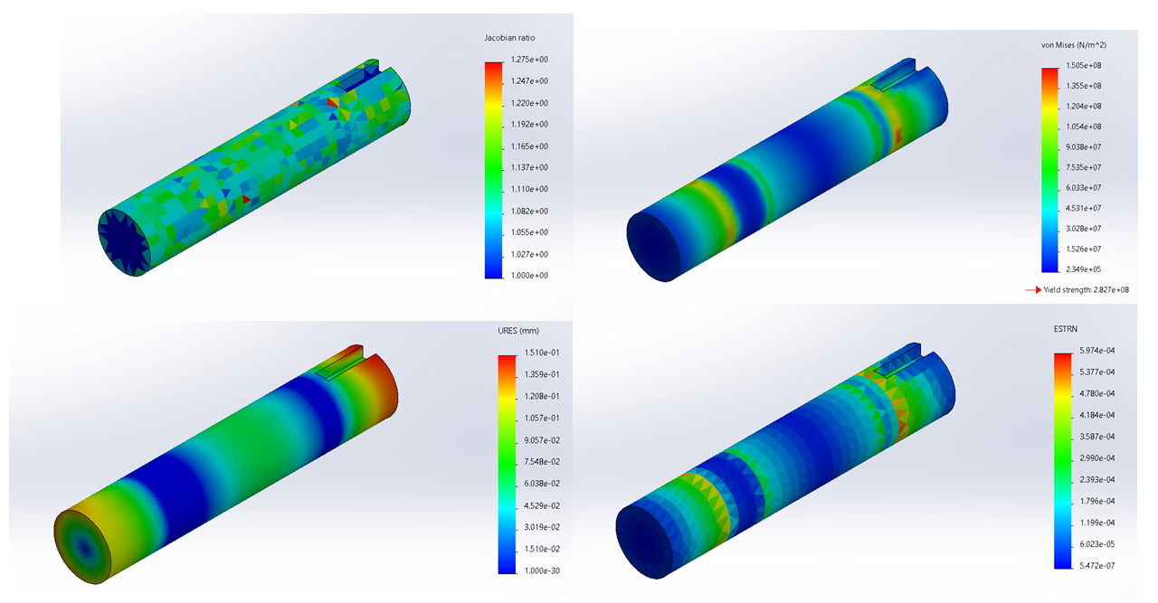Figure 20: Mesh, Stress, Deformation, and Strain analysis of main shaft.

* 1. **Gear**

Gear 1 is applied a torque of 305.63 kN.m, Gear 2 and 3 are applied a torque of 86.44 kN.m, and Gear 4 is applied a torque of 24.45 kN.m. The simulation of FEA of them are shown in the appendices part. By looking at these figures, we can see that gears are able to withstand the torque applied to them.

# **Discussion and Conclusion**

As engineer perspective, the design of the wind turbine's components in this project has some good points and problems as well. These good things are the parts are calculated and chosen in the demand of the client and they are available on the market. All components are well linked together and give acceptable result. However, since several design specifications are lacking which force us to make assumptions, the result is not really accurate. For example, initially, we assume the length of shafts is quite short which made the diameter become large compare with the length. This led to the components of the wind turbine are larger. If the design time of this project is longer, we can redesign the components to make them more appropriate.

As student perspective, this project helps us a lot in the future study and career such as how to apply theory to real life’s problem, what is the strategy in the design process, and applying software in the design as engineer, etc.

In conclusion, thank to practical assignment 2 - Mechanical Engineering Design and Analysis, we are able to understand the fundamental principles of wind turbines and each component. Moreover, we knew how to use Solidworks not only for drawing and designing components but also analyzing the motion of the wind turbine as well as behavior of the components like stress, strain, and deformation. Although the design is not really perfect, it is in the acceptable range and designed based on client’s information. This assignment is helpful and going to support us in future.

# **Reference**

[1] M. Tran, "Key Design - Note 1", rmit.instructure.com. [Online]. Available: <https://rmit.instructure.com/courses/96228/pages/supporting-documents-for-week-6?module_item_id=3570531>. [Accessed: 03- Jan- 2022].

[2] "Gear Trains", Iitism.ac.in. [Online]. Available: https://www.iitism.ac.in/~shibayan/MCC%2013103%20Kinematics%20of%20Machines/TOM%203BT%2014-15%20lecture%20set-6%20_Gear%20Train_KG.pdf. [Accessed: 02- Jan- 2022].

[3] "Bearing Design - Note 1", rmit.instructure.com. [Online]. Available: https://rmit.instructure.com/courses/96228/files/20785402?wrap=1. [Accessed: 06- Jan- 2022].

[4] "Reading+Note+Breakes+Clutches+Cited+Fundamental+Machine+Elements", rmit.instructure.com. [Online]. Available: https://rmit.instructure.com/courses/96228/pages/supporting-documents-for-week-10?module_item_id=3570589. [Accessed: 03- Jan- 2022].

[5] "EN8 Steel Properties BS970 080M40 Equivalent Material Tensile Yield Strength", Theworldmaterial.com. [Online]. Available: https://www.theworldmaterial.com/bs970-080m40-en8-steel/. [Accessed: 03- Jan- 2022].

[6] "Wind turbine blades: Big and getting bigger", Compositesworld.com, 2008. [Online]. Available: https://www.compositesworld.com/articles/wind-turbine-blades-big-and-getting-bigger. [Accessed: 04- Jan- 2022].

[7] "Lift/Drag Ratio, Forces Interaction and Use", SKYbrary Aviation Safety. [Online]. Available: https://skybrary.aero/tutorials/liftdrag-ratio-forces-interaction-and-use. [Accessed: 03- Jan- 2022].

[8] "Gear Train : Gear Ratio, Torque and Speed Calculations", SMLease Design. [Online]. Available: https://www.smlease.com/entries/mechanism/gear-train-gear-ratio-torque-and-speed-calculation/. [Accessed: 01- Jan- 2022].

[9] "Shaft Design - Note 1", rmit.instructure.com. [Online]. Available: https://rmit.instructure.com/courses/96228/pages/supporting-documents-for-week-6?module_item_id=3570531. [Accessed: 03- Jan- 2022].

[10] "Rolling bearings", Skf.com. [Online]. Available: https://www.skf.com/binaries/pub12/Images/0901d196802809de-Rolling-bearings---17000_1-EN_tcm_12-121486.pdf#cid-121486. [Accessed: 03- Jan- 2022].

[11] "What bearings are used in wind turbines?", Acorn-ind.co.uk, 2020. [Online]. Available: https://www.acorn-ind.co.uk/insight/what-bearings-are-used-in-wind-turbines/. [Accessed: 07- Jan- 2022].

# **Appendices**

## **Shaft**

## **Key**

## **Gearbox**

**Gear 1:**

**Gear 2:**

**Gear 3:**

Gear 4

## **Bearing**

## **Brake and Clutch**

Table : Dimensions and Load ratings for Cylindrical Roller Bearings.[10]

Table : Properties of materials operating dry, when rubbing against cast iron or steel. [4]

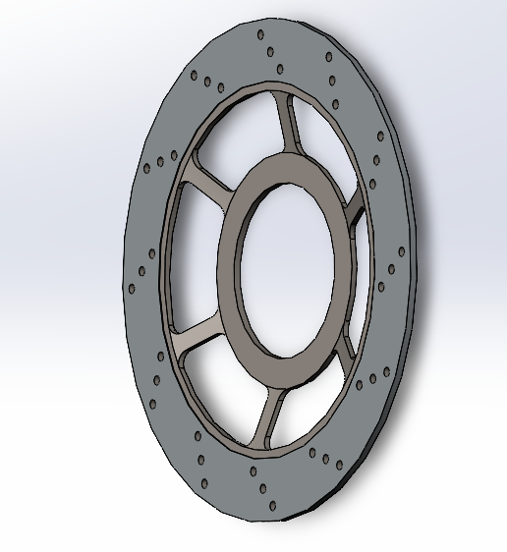

## **Final design**

